What is the theme of your game?
- The theme of the game is an escape from a medieval castle. This castle has magical secrets, and mysteries.

What is an image that sums up your game theme?
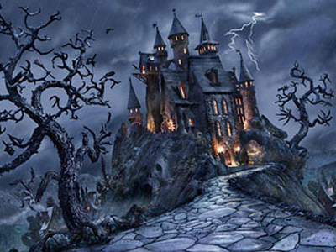
Who is the player?
- The player is a prisoner.
What is the goal?
- The goal is to escape the castle by going in certain directions, and solving puzzles.

